St Mary’s Eco Church
Registration form for Wednesday Eco Group

The group – for young people in Years 6-11 - will meet in and around the Meeting Room directly next to the playground in Archbishop’s Park, SE1 7LE. Within the park, the group will take part in a range of outdoor eco activities such as planting, harvesting of apples, taking care of the pond, weeding, and other gardening activities with adult supervision (1 adult for every 8 children, following Diocesan safeguarding guidelines). Before and after the eco activities there will be snacks and food provided.

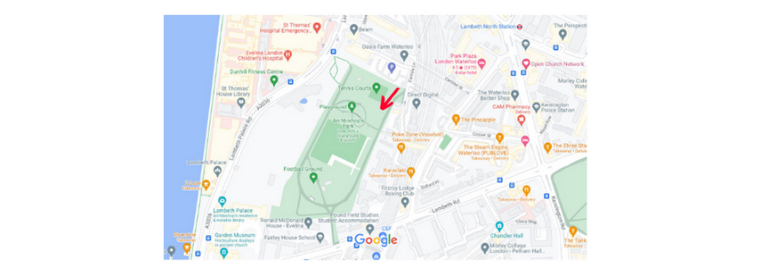

To be completed by parent/carer/guardian.

Family contact details:

Child’s full name: Date of birth:
Full name of parent/guardian:

Child’s home address:
Home telephone:

Parent’s/guardian’s mobile number:
Parent/guardian’s e-mail address:

Family doctor:

School: School year:

About your child:

Does your child have any food allergies (please specify)?

Does your child have any medical conditions (please specify)?

Is your child on any medication (please specify)?

NHS number: Details of last anti-tetanus injection:

Does your child have any special needs (please specify)?

Is there anything else you would like us to know about your child?

Emergency contact details for parents/guardians:

Contact telephone number during group or activity time:
Contact name for an alternative adult in case of emergencies:

Alternative adult’s telephone number:
Alternative adult’s relationship to your child:

Arrangements for collection:

My child will be brought and collected from the group: YES / NO
My child will be collected by: Relationship to child:

Name of anyone NOT allowed to collect my child: Relationship to child:

My child has permission to travel to and from the group
without me (children over 11 years): YES / NO

Declaration:

I give permission for (child) to attend and take part in the
specified activities.

In an emergency and/or if I am not contactable, I am/am not (delete as appropriate) willing for my child to receive medical or dental treatment including an anaesthetic.
Signed (parent/guardian): Date:

Your privacy is important to us and we are committed to keeping your personal information confidential and secure. For more information on how we process your data, please see our privacy notice which is available on the parish website at www.northlambethparish.org and noticeboard at St Anselm’s Church, Kennington.

This form should be updated annually.

